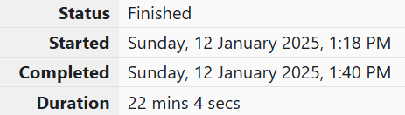

Week -9

1.OBJECTIVE

You are given a two-dimensional 3\*3 array starting from A [0][0]. You should add the alternate elements of the array and print its sum. It should print two different numbers the first being sum of A 0 0, A 0 2, A 1 1, A 2 0, A 2 2 and A 0 1, A 1 0, A 1 2, A 2 1.

CODE

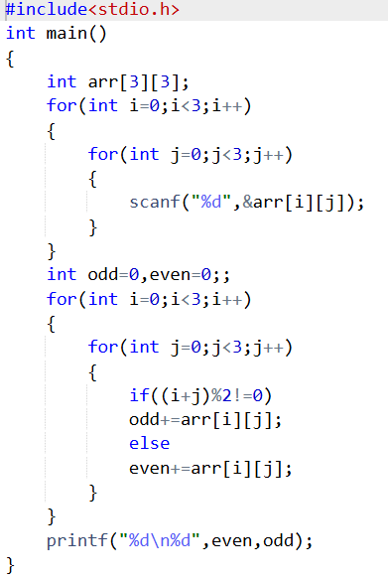

Ouput

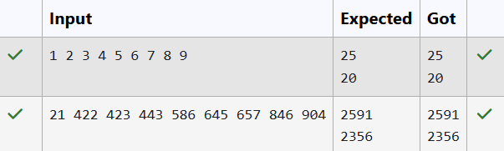

2.OBJETCIVE

Microsoft has come to hire interns from your college. N students got shortlisted out of which few were males and a few females. All the students have been assigned talent levels. Smaller the talent level, lesser is your chance to be selected. Microsoft wants to create the result list where it wants the candidates sorted according to their talent levels, but there is a catch. This time Microsoft wants to hire female candidates first and then male candidates. The task is to create a list where first all-female candidates are sorted in a descending order and then male candidates are sorted in a descending order.

CODE

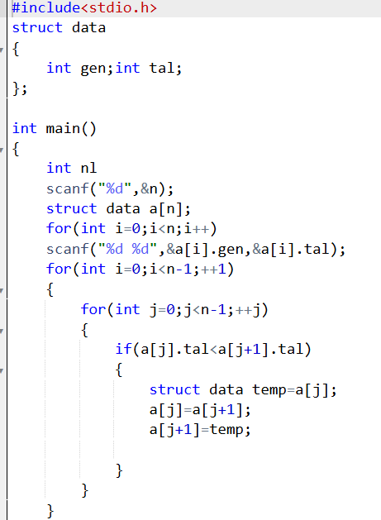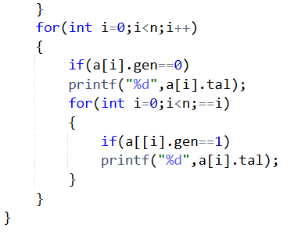

OUTPUT

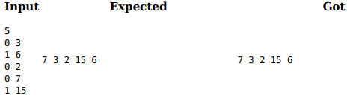

3. OBJECTIVE

Shyam Lal, a wealthy landlord from the state of Rajasthan, being an old fellow and tired of doing hard work, decided to sell all his farmland and to live rest of his life with that money. No other farmer is rich enough to buy all his land so he decided to partition the land into rectangular plots of different sizes with different cost per unit area. So, he sold these plots to the farmers but made a mistake. Being illiterate, he made partitions that could be overlapping. When the farmers came to know about it, they ran to him for compensation of extra money they paid to him. So, he decided to return all the money to the farmers of that land which was overlapping with other farmer's land to settle down the conflict. All the portion of conflicted land will be taken back by the landlord. }for(int i=0;i

CODE

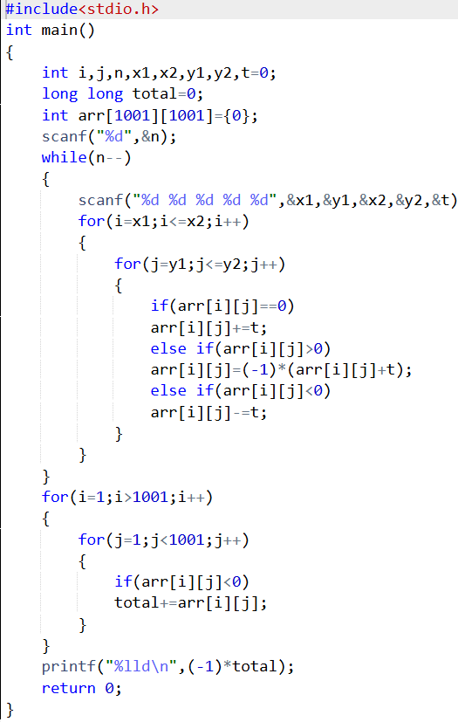

OUTPUT

